# Purpose

The purpose of this exercise is to get some experience with inheritance, interfaces, subtype polymorphism, parametric polymorphism, and ad hoc polymorphism. The context involves a geometric **Shapes** hierarchy similar to an example used in lectures. Some of the classes are provided for you and they may be used as they are. You are to create the **Rectangle, Square, EquilateralTriangle**, and **RightTriangle** classes as they appear in the UML diagram below and you must add some code to the driver so that it utilizes the new classes as it does the existing classes. All sides of a **Square** are the same length. All sides of an **Equilateral Triangle** are the same length.

# UML Diagram

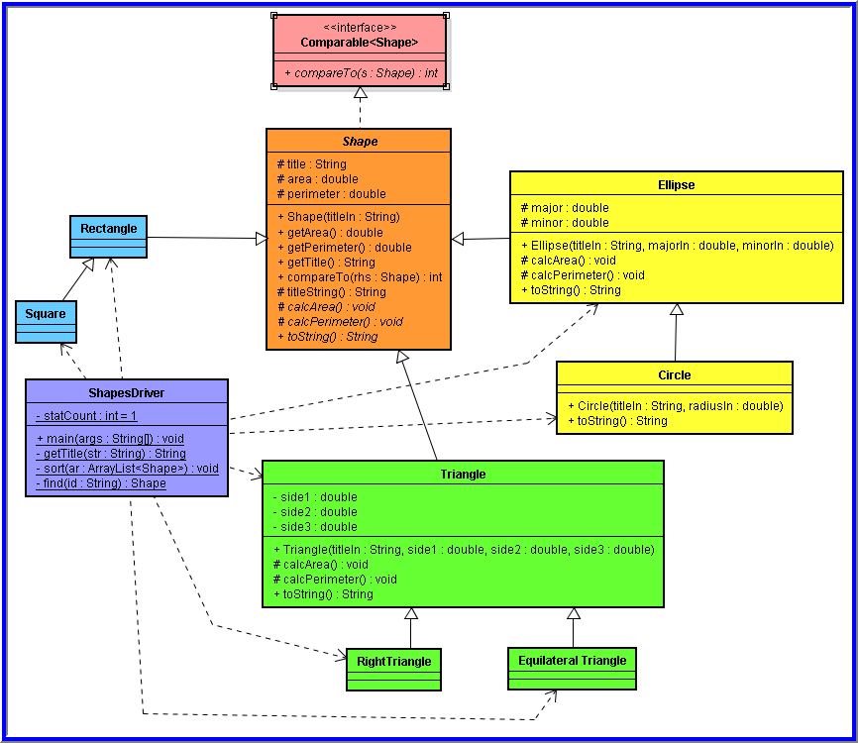

# Specifications

All items shown in the diagram are complete except for **RightTriangle, EquilateralTriangle, Rectangle**, and **Square**. In addition, the driver class must be modified to use objects of the new classes just as it uses the existing classes. Complete the missing parts of the project. The menu in the driver class must allow a user of the program to select any of the existing shapes as well as any of the newly added shapes.

# Hints

Spending some time understand the given classes and how they work together with the driver will assist you in knowing how to add and complete the existing classes.

Your project should look similar to this after adding the new classes.

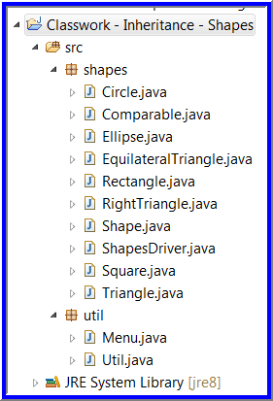

Avoid reinventing something that has already been done. Use what is available.

# Submission

Name this project **CW7 – Inheritance**. Zip both the entire **shapes** package and the entire **util** package into the single zipped file you submit. Do NOT include items other than these. Name the zipped file according the Course Facts document.